C2 | Round Robin vs SRTF Comparison Project

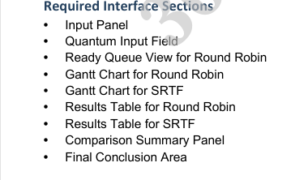
Gui/
Requirement
Input Panel | input_panel.py
Quantum Field | input_panel.py
Ready Queue | main_window.py
Gantt RR | gantt_chart.py
Gantt SRTF | gantt_chart.py
Results RR | results_table.py
Results SRTF | results_table.py
Comparison Panel | comparison_panel.py
Final Conclusion | comparison_panel.py

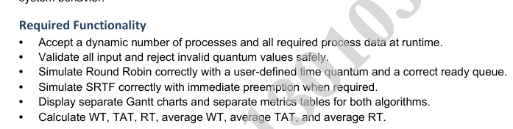

Requirement |  | File
 | Accept Processes | process.py
 | Add Process | input_panel.py
 | Validate Quantum | input_validation.py
 | Validate Process | input_validation.py
 | Round Robin | round_robin.py
 | SRTF | srtf.py
 | Draw RR Gantt | gantt_chart.py
 | Draw SRTF Gantt | gantt_chart.py
 | Calculate Metrics | metrics.py
 | Calculate WT | metrics.py
 | Calculate TAT | metrics.py
 | Calculate RT | metrics.py
 | Display RR Table | results_table.py
 | Display SRTF Table | results_table.py

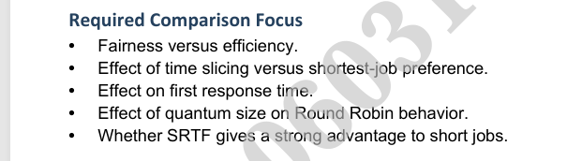

Requirement | File
Fairness vs Efficiency | comparison.py
Time slicing effect | comparison.py
Response Time effect | comparison.py
Quantum effect | comparison.py
Short Job Advantage | comparison.py
Final Conclusion | conclusion.py
Show Summary | comparison_panel.py
Show Conclusion | comparison_panel.py

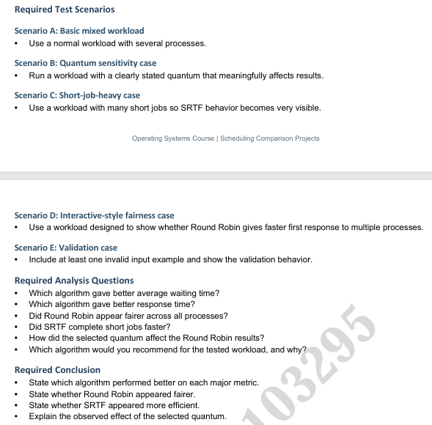
Requirement | File
Scenario A | test_cases/scenario_A.txt
Scenario B | test_cases/scenario_B.txt
Scenario C | test_cases/scenario_C.txt
Scenario D | test_cases/scenario_D.txt
Scenario E | test_cases/scenario_E.txt
Run Scenarios | analysis/test_runner.py
Analysis Questions | analysis/comparison.py
Recommendation | analysis/report_generator.py
Final Conclusion | analysis/conclusion.py
Display Conclusion | gui/comparison_panel.py

